Overview

High Power Ultrasonic Impact Treatment

A new innovative ultrasonic method

Ultrasonic Impact Treatment (UIT), Ultrasonic Impact Peening (UIP), Ultrasonic Hammer Peening, Ultrasonic Needle Peening (UNP), Ultrasonic Peening (UP), and High-Frequency Mechanical Impact (HFMI) processes can be used to describe the same technology using high power ultrasonic systems to make surface impact peening treatments.
Ultrasonic Impact Peening is a cold working process that uses high frequency and high-velocity impact of a hard metal tool tip to plastically deform a material in order to introduce beneficial compressive residual stresses. These residual compressive stresses are produced by work hardening with the intent to replace residual tensile stresses in metal surfaces and welded joints. In weld joints, one significant objective is to improve the fatigue strength of welds that may be subject to dynamic stress conditions and susceptible to stress cracking.

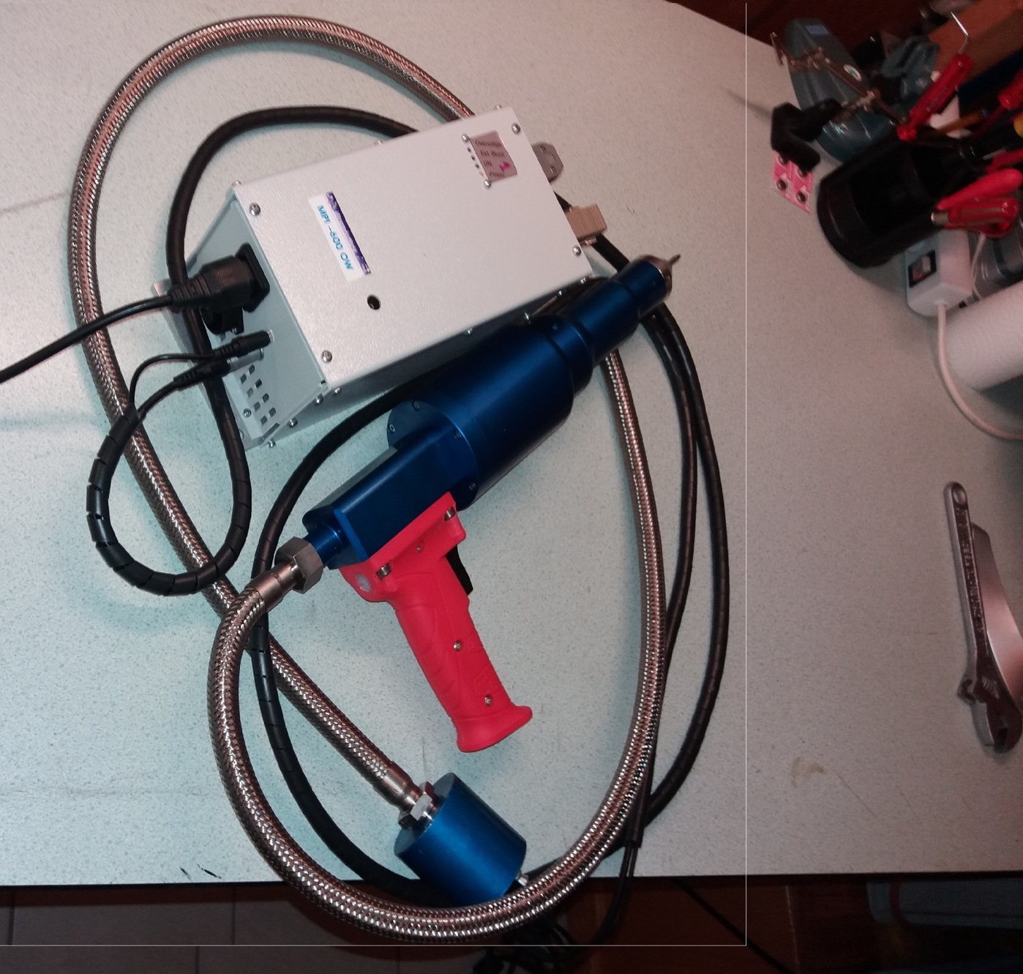

Many structural weldments – Ships, Offshore platforms, cranes, bridges, big reservoirs, big metallic constructions and machinery, antennas, and other structures are subject to the action of large number of cyclic loads during service.
The development of fatigue fractures amounts to approximately 30% of the total premature failures in these structures.
The fatigue limit of butt welds in different strength classes of steel established by the criterion of fatigue crack initiation is reduced to 32% to 46% of the fatigue limit of corresponding parent metal with a rolled surface. Similarly, the fatigue limit of lap joints with longitudinal fillet welds under cyclic stress conditions constitutes only 20% to 40 % of the fatigue limit of the corresponding parent metal.

- It is a fatigue life improvement technique of welded structures by application of ultrasonic and mechanical impulses at the high stress locations in the weld. As a result of ultrasonic and mechanical impulses the welded metal is modified at the atomic- and/ or metallurgical- level.
- It introduces compressive residual stresses (up to 900Mpa at and near the surface), increases hardness, corrosion resistance and improve the quality of the surface.
- It increases hardness by 10% and improved surface quality by 50%.
- Reduces stress concentration associated with weld local geometry.
- Creates plastic deformation strain hardening in a surface layer (up to 0.7 mm in depth).
- It improves the fatigue life of the structure by approximately a factor of 10. This improvement is mainly because of reduction of tensile stresses, introduction of compressive stresses, increase in hardness and improvement of surface quality.
- Ultrasonic peening treatment can be applied to a wide range of metals including steel, cast-iron, aluminum, Inconel, titanium, stainless steel and bronze.
- For cylindrical parts, the UP treatment is also available due to possibility of rotation of the component. Hence UP device designed for robotic use can easily be adopted to lathes and milling machines.
- It is the most efficient and easy to apply technique on the welded structures.

- 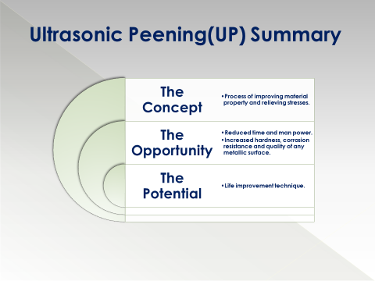

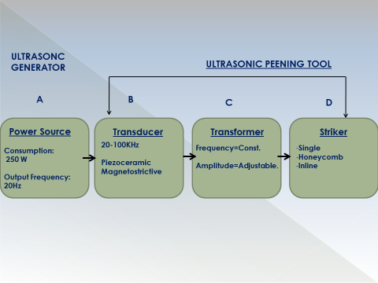
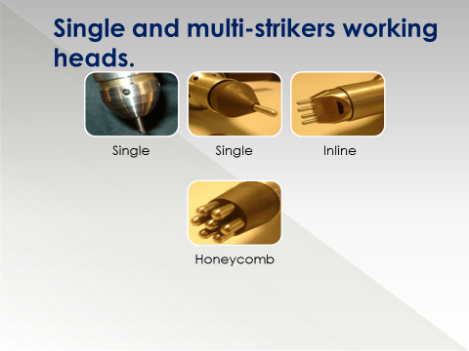
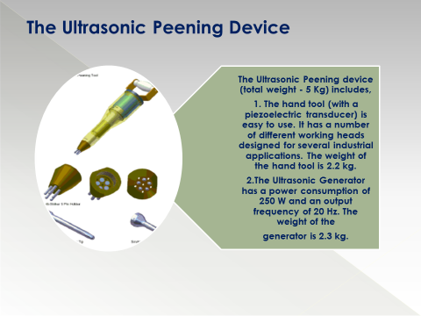
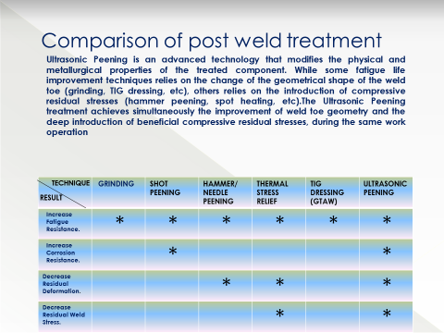
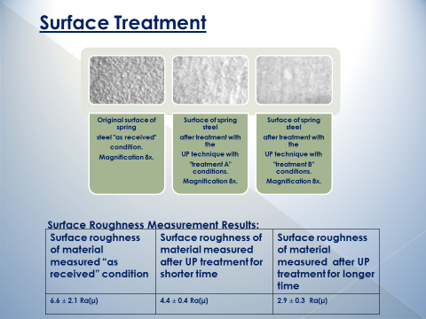

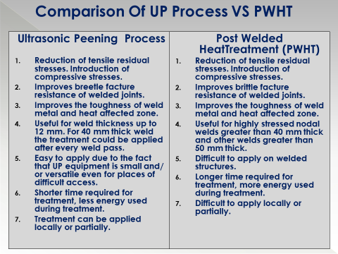
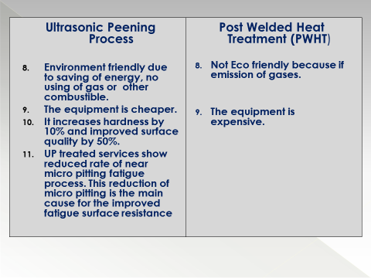
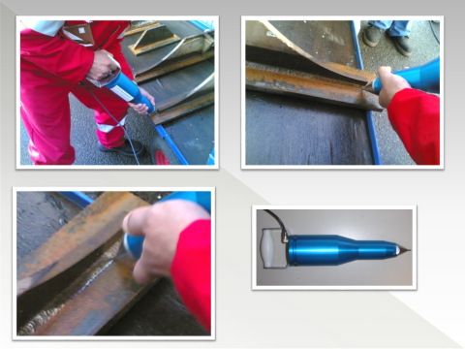
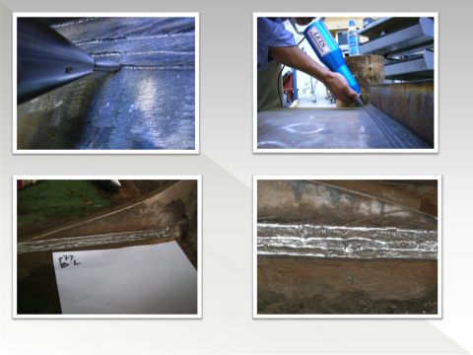

THE problem
Example: Weld joints on offshore rigs are subject to constant stress and strain due to rough sea conditions. The same is true for Floating Production Storage and Offloading (FPSO) vessels that are additionally subjected to the stresses of the cyclical loading, especially in fatigue prone areas. As the rig and vessel welds approach the end of their known fatigue life our clients are faced with the challenge of repairing and maintaining failing weld joints. Normal repairs to these high stress joints are often temporary and not sufficient for long term operation. By using our Ultrasonic Peening technology to dress repaired welds and also treat undamaged welds in high stress areas our clients can reset the fatigue life and add up to fifteen years of additional service life.

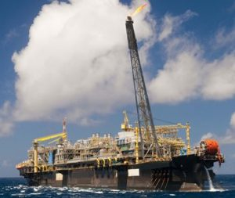

The Solution
Ultrasonic peening can be the best option for fatigue life improvement of FSO & FPSO welds in high stress areas. The Ultrasonic peening technique involves the cold working of the weld toe and weld face and can improve the fatigue strength of full penetration weld configurations by up to four times.
Welds identified at particular points of structural integrity are targeted for Ultrasonic Peening treatment. The fatigue life extension of those specific welds will offer a general life extension of the offshore structure or vessel. This type of treatment is currently used to avoid or prevent fatigue cracks in high stressed weld connections in offshore structures.
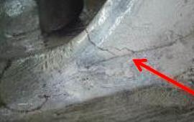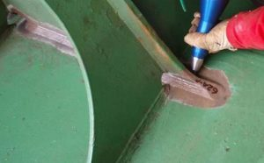

The Advantage
The power supply equipment is the heart of the UP system and is based on proprietary MMM Technology, which produces high efficiency active power in wide-band sonic and ultrasonic vibrations. The peening tool is enabled to produce proprietary “single-piston” peening action, and every other peening tool known from other sources (from competitors) is based on double-piston action. In essence, by utilizing the proprietary peening action, a much deeper metal penetration (up to factor 2) is achieved.
Our design team can provide custom pins and pin holders for almost any application. We offer standard tool designs working at 20 kHz and 35 kHz.
Enhance low and high cycle fatigue and has been documented to provide increases of up to ten times greater than non-treated ultrasonically peened.
Example (non referenced)
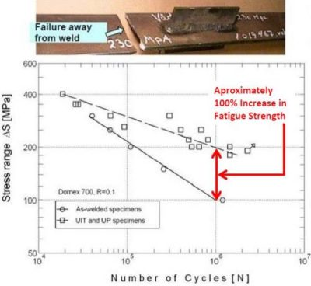

The Product
The ultrasonic impact peening system includes an ultrasonic generator power supply connected by a cable hose to the tool housing that contains an ultrasonic transducer assembly and the impact pin(s). The tool-housing tip holding the impact pin(s) is replaceable and can be designed in a wide range of options to allow for one or many pins in various arrangements to address many different applications. The tool housing can be optioned for hand-held operation or mounting to a robotic arm for automated applications.
Our design team can provide custom pins and pin holders for most any application. We offer standard tool designs working at 20 kHz and 35 kHz. Other custom frequency system are available on demand.
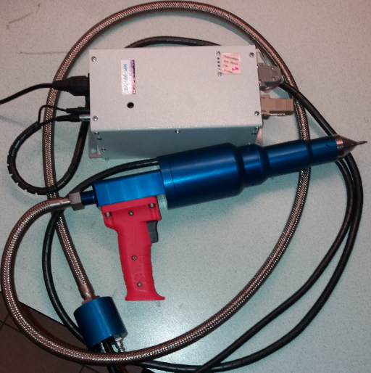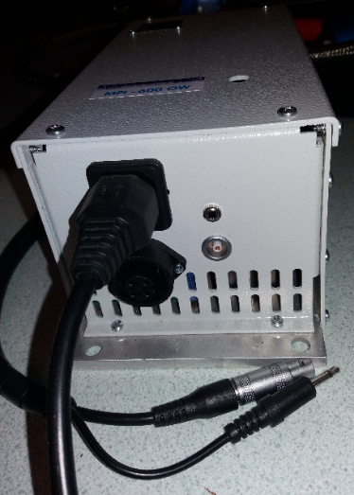

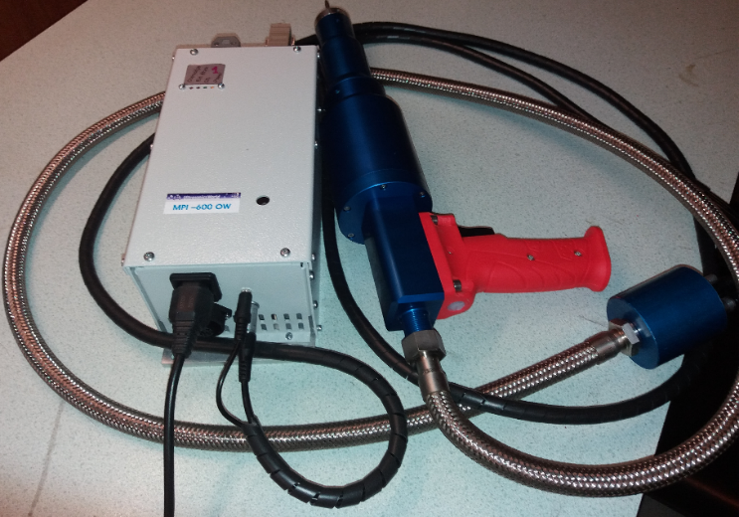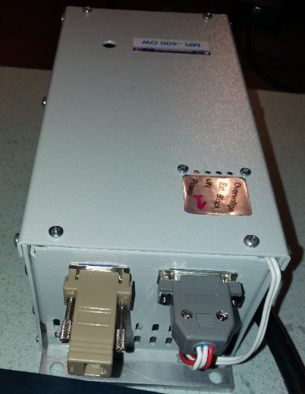

Specification, advantages and properties:

- MPI peening tool has 2 times higher, initial oscillating amplitude of ultrasonic transducer, compared to any other peening tool produced worldwide (meaning hammering, penetration impact depth can be very high and strong). It also has and stronger pulsing momentum (at least two times), than anybody else.

- MPI’s peening operating regime is frequency-modulated what has advantages regarding faster and stronger stress relief (compared to competitors).

- MPI peening presents Single-piston peening concept based on the patent applications:
a) European Patent Application: EP 1 060 798 A1. Unidirectional single piston ultrasonic transducer. Applicant: Prokic Miodrag, MP Interconsulting, 8.06.1999 – 20.12.2000
b) European Patent Application (related to MMM technology): EP 1 238 715 A1
Multifrequency ultrasonic structural actuator
Applicant: Prokic Miodrag, MP Interconsulting, 5.03.2001 – 11.09.2002
Single-piston agitation is penetrating much deeper than double-piston concepts of all other peening tools from competitors.
- MPI Peening generator keeps frequency and power control during peening in heavy-duty conditions what is very difficult for standard ultrasonic generators.

- Operating life: almost unlimited. Apparatus is very robust and almost indestructible, compared to competitors. Applicable in very long continuous operating regimes (it has forced air-cooling for very long and heavy duty operations).

- Modular design concept, with easy replaceable hammering pins, and handy for manual operations.

- Can be applied with robotic arm.

- Rated watt consumption 400-600W.

- Operation ultrasonic frequency 20 kHz (higher frequencies also available).

- Bias current 7A.

- Oscillation amplitude of wave guide edge 25-30 μm.

- Treatment speed in manual mode 0,3 - 0,7 m/min.

- Overall dimensions of manual tool 455x180x75 mm.

- Manual tool’s weight 3,5 kg

- Tool’s axial clamping force 20-40 N.

- Cooling air input.

- Single pin and multi-pin heads.

- Needle diameter 2 to 5 mm

Ultrasonic generator:
- Output voltage 600-1200 V
- Main supply voltage 230V 50/60 Hz
- Operational frequency range 17.5 - 21 KHz

